### Week 1 - Hybrid, reading only

### Week 2 - virtual

1. M (30 min)

Agenda

* Introduce self, go through Moodle page and file types (update to 3rd def and terms file)
* Pause questions (check can see student responses to reflection prompt)
* Access and knit HW 1 template (Muses introduction Annie (sec 1) and Victoria (sec 2)) (second session will be recorded and accessible)
* Announcement - office hour poll (30 students need to respond), virtual OH this week Th from 2-3:30pm

Notes: Did a much better job explaining library/packages analogy in Sec 2. Working on problem at library. 1st make sure books are on the bookshelf of the library (install packages), then take off shelf to use at your desk (call package with library function)

1. W (30 min)

Agenda

* Announcements: Correction to HW 1 prob 7, office hours tomorrow 2-3:30, class recordings on Moodle, completion 100% on reading quizzes (​​The reading quizzes will count as "complete" once you have a score of 100% but you can take these quizzes as many times as you need to get to 100%)
* Introduce worksheet and how to run R code chunks, groups work on worksheet, visit breakout rooms
* Reflection prompt; prob 10 in class on Friday

Notes: In sec 1 only 10 students in attendance. Need to give instructions on how to convert from html to pdf and need to go over prob 9 on Friday b/c did not give two sample prop notes in reading assignment for this or prob 10. In Sec 2 had at least 18 in attendance. Groups in general got further with the worksheet but used offline versions of RStudio. Ran out of time and forgot to announce reflection prompt in Sec 2. TAs noted a typo in the table for Problem 2 HW 1 (totals don't add correctly) and that students really struggled with the concept of a sampling distribution.

1. F (30 min)

Agenda

* Worksheet from last class finish and review: <https://drive.google.com/file/d/1eTFt_TmQc9HiTVLe-CSJAma3Grl3dyX_/view?usp=sharing>

RStudio - preamble, questions, answers, code chunks, order of code evaluation; showing work for non-R problems

(1/28) * ((-0.09 - 0.079)^2 + (-0.09 - 0.079)^2 + (-0.01 - 0.079)^2 + … + (.25 - 0.079)^2)

* how to do two sample tests in r with prop.test example
* Reflection prompt (due by midnight)
* Class policies and feedback course expectations form <https://docs.google.com/forms/d/e/1FAIpQLScCeZJduDwZBW8tI7BJLqXkwN_6MPUyvtsglPYQBO91nwfjaQ/viewform?usp=sf_link>

Notes: (Distinguish OH and muse/clinic hrs on end of semester feedback form); need to announce hw solutions must include interpretation within the context of the problem and give an example (done via Moodle announcement); need to incorporate communication and test policies into syllabus (they were announced) also link to class policies form in moodle

### Week 3

1. M

Agenda

* sampling distribution concept picture - anything that is a function of the data has a sampling distribution
* Problem 6 concept of statistical reasoning, not just one number different from another but taking into account sampling variability under an assumed model
* Procedures and tests covered so far: one and two sample propn, in R by hand and with prop.test()
* R work: HW 2 - prob 6 data entry, (ignore brand, mimic table), calculate mean data$varb; histogram with ggolot
* HW 1 - how to write answers for full credit
* Get to know at least 2 other classmates who aren't in current group

Notes: only need about 5 mins for getting to know other at end and forming initial groups; make sure to write on board notes from left to right and track camera along; take breaths in between! Running out of breath too easily. When distracted or finished, pause, check camera, time, questions. Don't rush into new topic.

1. W

Agenda

* Moodle - professor expectations, hw solutions
* modeling: choose, fit, assess, use (so far Normal, or t-distribution) Ch 1.1
* Simple linear model - conditions, concept, notation
* Reflection prompt

Notes: published signed agreement for class expectations of professor, besides reflection prompt and introducing moodle material, class was a classic blackboard lecture. Some students asked questions, I made sure to encourage them but need to pause and intentionally ask questions like "symbol you don't understand" or "concept that isn't clear" or "need examples?" want to get better about setting more time for reflection, maybe do this at beginning of class?

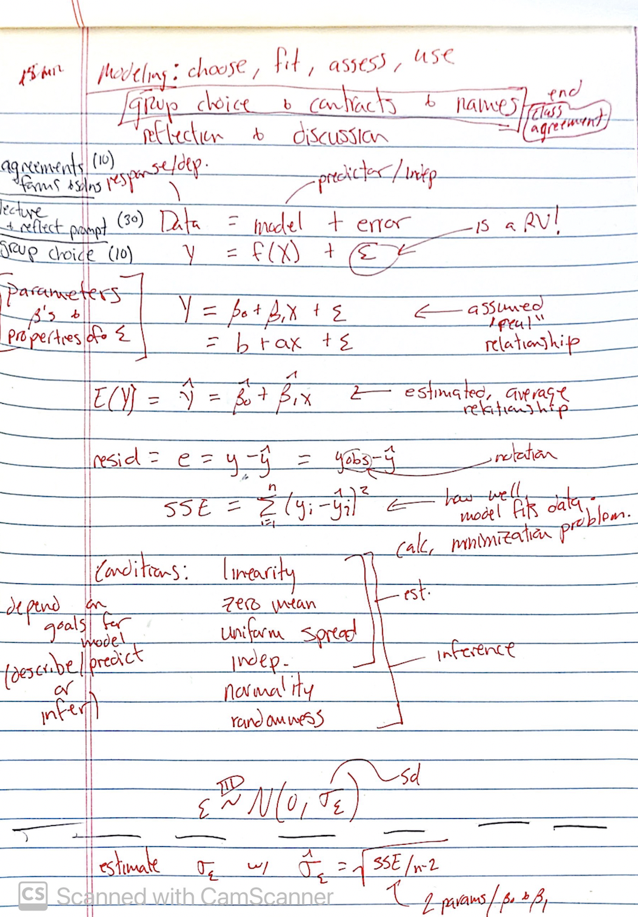

1. F

Agenda

* Choose groups, names, sign contracts
* Questions from reading quiz:

I'm confused about how to know which test to use for a problem.

I would love it if you were able to cover more of the details behind confidence intervals and the process of running different types of tests for different scenarios/different desired results.

* Worksheet about which test/procedure to use
* Linear model - review notation from last class, introduce sigma hat; discuss assessing with normal quantile plot and normal probability plots

1. Linearity
2. Zero mean
3. Uniform spread
4. Independence
5. Normality
6. Randomness

Randomness and independence?

* Is [n<10% population] sufficient to accept the assumption of an SRS?

Linearity and uniform spread - e vs y_hat; introduce estimate for Var(epsilon)

Normality - Normal quantile or probability plot (straight line either way)

Notes: In Sec 1 mixed up x and y axis of residual plots so make sure to go over this again (and how to interpret for linearity and for constant spread). Also, worksheet needed edits so make sure to mention these edits to Sec 1. Announced spending more time on Ch 1 and SLR material. Take note of students who haven't submitted HW 1 or HW 2 and those that aren't in groups

### Week 4

1. M

Agenda

* R worksheet - fit SLR, plot residuals, normal plots, etc (Ch 1)
* 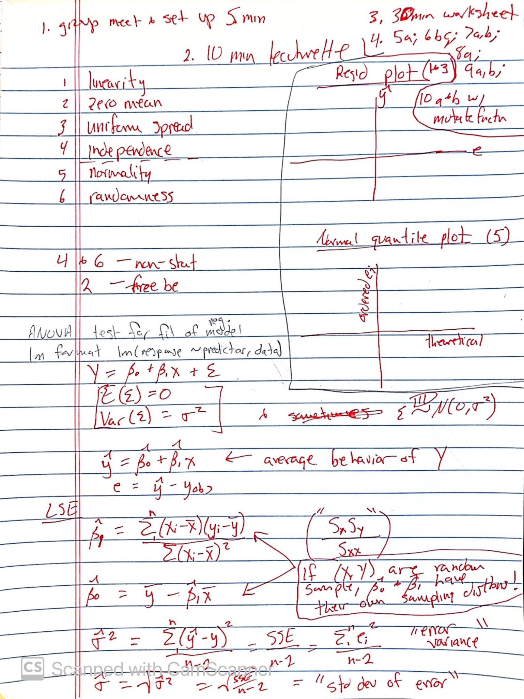

Notes: Sec 1 groups got through Q3, told to finish worksheets on their own bc will go over quickly in class on Wednesday. Also told worksheet contains the code necessary to do problems 5 -10 (10 needing the mutate() function) Extending due date for HW 3 to sunday at midnight.

1. W

Agenda

* Review worksheet quickly - emphasize assessing necessary conditions
* Tests for: significance/fit of regression model (with anova()),

Notes: Accidentally spend more time on reviewing worksheet because went into details of the code and changed up piping notation so wanted to sort that out and clarify. Moodle calendar had the wrong test date so deleted it.

Student (Koji) visited in office hours today to (respectfully) tell me that he's bored in class and prefers to study on his own. I don't know what to do. I can't make every single student happy. He is a Stat major however. I thought testing out of Stat 21 was an option but it isn't for majors (they have to take at least Stat 11 or 21 here). So what to do?

1. F

Agenda

* Reflection prompt - begin with, review last weeks (5 mins for)
* Mentioned how to interpret coefs for models of transformed Y
* R^2 coefficient of determination to assess fit and formula of
* significance of predictor (SE of beta_hat and CI also)

Notes:

### Week 5 - Test 1

1. M

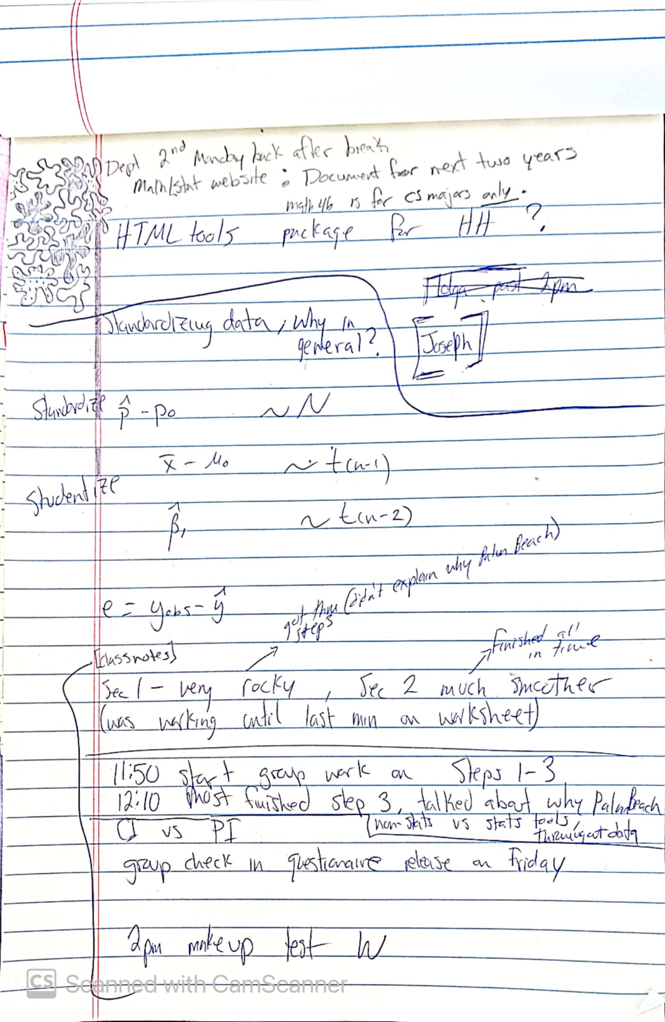

Agenda

* Go over which team won friday's competition, moral to always put something (miss 100% of the shots you don't take)
* introduce /review concept of standardization and studentization (for any quant vector, for sampling distributions, for residuals). Whole point is comparison. Relative weirdness.
* Groups worked on week 5 worksheet, little to code

**Notes**: Sec 1 was pretty rocky because I was working on the worksheet up until the last minute, section 2 went much smoother, finished on time.

Student feedback (Koji) to intentionally include more pausing, time to think of answer on own (not necessary soliciting spoken answer) before revealing reason/equation/etc

**Finished prep early:** no

**Finished class early:** no in Sec 1, yes in Sec 2

1. W

Agenda

* Questions from last week's reading quiz
* PIs and CIs
* Review for test

**Notes**: went over last classes' worksheet with Sec 1 so they got less review time overall and they haven't actually gone over the entire worksheet yet. Mentioned that will discuss independence assumption next week

Finished prep early: no, was working on test 1 still and last minute created the reflection prompt (while in class actually)

Finished class early: no in Sec 1,

1. F

Agenda

* Test 1: Ch 0 - 2 and review

**Notes**: got feedback from Phil on possible ambiguity and typos and I think that helped a lot. Only had 1-2 student questions for both sections. USE THIS VERSION OF EXAM IN FUTURE.

### Week 6

HW 4 has some significant typos. Make sure to go back and rework. Pay careful attention to wording of Problem 5 in particular. Accept either answer sample sd of observed Y OR sigma_hat estimate. Then discuss in class the distinction. (There's a parallel here to ANOVA models, when to use sample sd to describe variability vs when to use the model based estimate.)

1. M

Agenda

* HW policy (match pgs, knitting and coding problems sorted out early on or no credit for R problems, ask about adding another drop HW grade); Test 1 graded by next monday (corrections for 1.5 credit due before spring break)l HW 5 due at end of spring break (but recommend not to procrastinate)
* SLR assumptions: constant variance (heteroskedasticity) and independence (time, space, genetics)
* MLR: think out how to write mathematical model and how to write code in R
* ~~Worksheet creating and plotting CI for mean and PI for unobserved in SLR, then add a variable and analyse with regression on its own, then combine~~
* HW 4
  + Transformation interpretation correction in Part I
  + Simulation study in part II (and what to focus on)
  + How to import data from external file for part II (go over in class)

**Notes:** Introduced importing external data into R Studio to begin on HW 4.

**Finished prep early:** no (right on time)

**Finished class early:** no in Sec 1 (was doing well until ran into coding issue), yes in Sec 2

1. W

Agenda

* Intro to Ch 3 - notation for MLR, i=1,..,n; j =1,...,k (and big data) , assumptions about \epsilon transfer to Y (independence and distribution) \mu_y notation for E(Y); mention interaction and polynomial terms and what a nonlinear model looks like; interpretation of coefficients (average change in Y for a one unit increase in X while allowing for simultaneous changes in the other predictors OR equivalently, while holding all other predictors constant/fixed/unchanging, like intercept doesn't always have a directly interpretable meaning in context of problem) also referenced HW prob2 and 3 re interpretation for transformations; terminology (input=predictor=covariate=RHS = indep; response=output=outcome=LHS=dependent) and history of indep/dep from Reg and Oth Stories book (pg 145)
* r^2 adjusted, \hat\sigma_2 for MLR (changing degrees of freedom)
* Reflection prompt about why some statisticians may not use t and F tests for regression (Reg and other stories book pg 147)

**Notes**: Reserve at least 30 minutes for reflection prompt as is (go back and try to simplify/reword for clearer message and purpose)

**Finished prep early:** No (got distracted with reflection prompt)

**Finished class early:** No in Sec 1 (want to leave at least 30 minutes at end of class for reflection prompt discussion)

1. F

Agenda

* Questionnaire to check in on group work feedback; OH's for today moved from 1-2pm
* Quick comments about reflection prompt with student responses and me giving feedback
* Reading quiz questions
* T-tests for beta's and f-test for overall fit
* Multicollinearity (sec 5.3)
* HW 4 problem 9 - plotting prediction bands worksheet

Notes: Didn't revisit syllabus and reminders about grade components or Mention decision about HW drops added to calendar. Kind of a lackluster class in both sections.

Finished prep early: yes

Finished class early: Sec 1 yes, Sec 2 yes

### Week 7

1. M

Agenda

* Indicator varbs (e.g. gender for discrimination) to compare slopes and intercepts (with interaction terms)
* E.g. predicting customer spending as a function of x1 = recency and x2 = 1, if has CC account with retailer (draw pics of lines with different intercepts and/or slopes); emphasize sigma2 is the same for each implied model; discussed "structural multicollinearity"
* Test 1 corrections: due by midnight Friday, scanned pdf separate page with name and each answer labeled

Notes: entirely lecture based class that I didn't prep for but jotted down textbooks topics to guide me (difficult personal stuff going on right now in my life)

Finished prep early: yes (barely)

Finished class early: Yes in both sections except for rushed Test 1 review in last 5 mins

1. W

Agenda

* Coding indicator varbs in R
* Fitting complete 2nd order interaction model in R (idea: have student groups pick different way to model same data and compare models/choose best one at the end of the class)
* ​​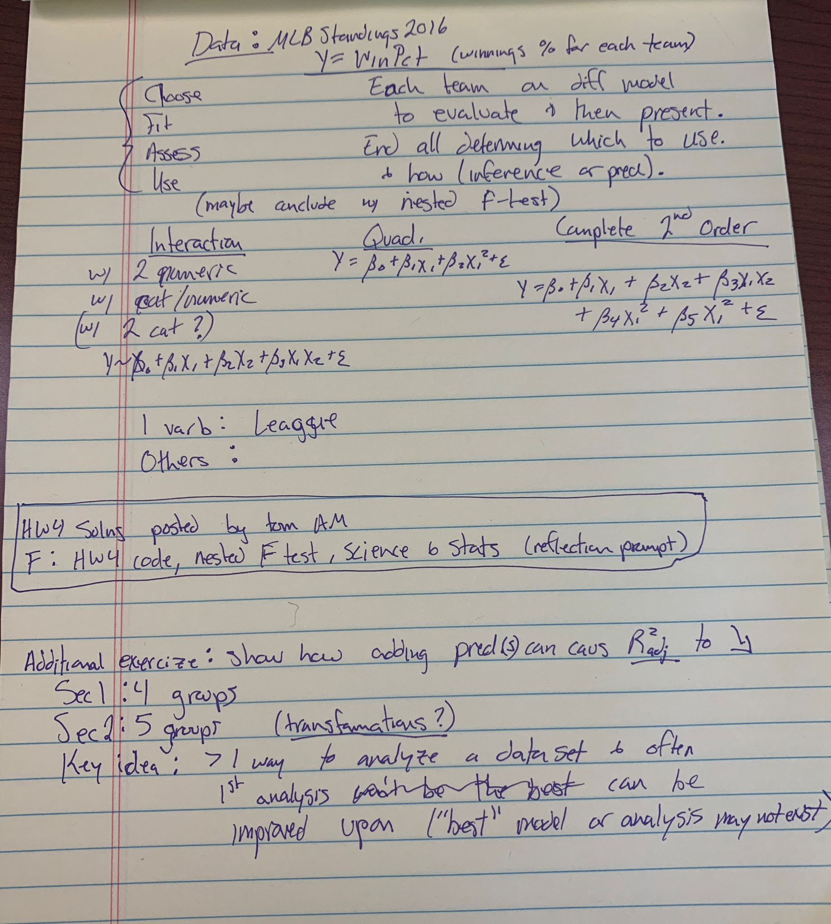

Notes: created worksheet and will assign different groups different models to fit and assess. Will present to class and decide on final model. Good opportunity to model the statistical consulting process: ask class if anyone knows anything about baseball (explain difference between AL and NL e.g.) and treat them as "domain experts". Ideally, each group using same set of predictors to set up for next class introduction of nested F-test

Finished prep early: Yes

Finished class early: Sec 1 no (too many typos and missing elements in worksheet, also long set up time going through each varb abbreviation)

1. F

Agenda

* Take some time to go over code from last HW (feedback from OH) re prob 4 and prediction intervals <https://embassy.science/wiki/Theme:Ae22e8ee-47a5-4f9d-bc00-a10de0011c76#cite_note-1>
* <https://www.amstat.org/your-career/ethical-guidelines-for-statistical-practice>
* Nested F test

Notes:

Finished prep early:

Finished class early:

### Week 8

1. M

Agenda

* Announcements: final project, mid semester evaluation, pause and reflect in HW too
* R worksheet to create a reference document of what "ideal" residual and normal quantile plots look like
  + Recap what these plots can tell us about
* Recap what changes when we have more than one predictor.
  + R^2 adjustments
  + Multicollinearity (structural or unintentional)
  + Careful interpretation of coefficients

Notes: in Sec 1, questions about residual vs time variable plot from HW 5 9a took up a lot of time (to do: eliminate that part of the question of the hw). In sec 2, I forgot to go over the HW 4 prob 4 simulation study and relate that to today's worksheet.

Finished prep early: yes (except final project)

Finished class early: No in Sec 1, Yes in Sec 2

1. W

Agenda



Notes:

Finished prep early:

Finished class early:

1. F

Agenda



Notes:

Finished prep early:

Finished class early:

### Week 9

1. M

Agenda

* R worksheet for Adirondacks models Q1-3

Notes: why include elevation if it's not seemingly related with time? Main point: all predictor varbs acting together in a different way than each predictor varb alone with the response. (In Sec 2 actually had a student who had hiked all these mountains)

Finished prep early: ?

Finished class early: In Sec 1 no, in Sec 2 yes

1. W

Agenda

* Moodle updates to reading assignment
* R worksheet finish up 4-6 and class discussion comparing models
* Wrapup with discussion on added variable plots (Q3)

Notes: Felt like a disaster of a class in Sec 1 but very improved in Sec 2 (after a small mental breakdown, Amanda's consolation, and a walk.

Finished prep early: ?

Finished class early: in Sec 1 no, in Sec 2 yes

1. F

Agenda

* Reflection prompt (3 mins alone, 4 mins group, 3 mins alone to finish up)
* Address question from reading quiz about # of predictor varbs vs terms
* MLR and Cars slides and then worksheet

Notes: going to email Sec 1 with time stamps for W recording (30.05-38.50) to clarify added varb plots, asked students to email me with intended partners for project and to work on pg 1 of today's worksheet on their own, and told Sec 1 that we will finish going over Monday's R worksheet next class

Finished prep early: No, worked up until the last second to finalize reflection prompt and worksheet

Finished class early: In Sec 1, NO, ran over by 2-3 mins. Sec 1 no, running out of time, didn't get to Model 3 on worksheet or to discuss anything as a class

### Week 10

1. M

Agenda

* Sec 1: spend 15 mins going over last week's R worksheet, model comparison Q4-6, point of added varb plots, spend 10 mins going over Friday's worksheet pg 1 and Model 1-3 comparison, interpreting coefficients as comparisons
* (Cross validation and ethical modeling considerations)
* Announce Test 2 will not include 4.6 or 4.7 material, some time on W then review for rest of W; no reflection prompt this week

Notes: pushed deadline for proposal till Sunday midnight; student question about if predictors are collinear then couldn't we just model them with structurally multicollinear model? My response was no b/c subtle difference between interaction and multicollinearity. Interaction multiplicative effect, included for system specif reasons. Multicollinearity unintended, redundant info, may combine terms in non-multiplicative way to create new varb.

Finished prep early: no, last minute putting together ethics slides (which are very sparse)

Finished class early: Sec 1 no ran over (got stuck on probl 3 part 1 of cars worksheet, didn't get to Rmd worksheet or cross validation, just introduced ethics slides); sec 2 no went up until time, student questions preventing moving forward (only got through pg 1 of MLR Cars worksheet, still have to go over model 3)

1. W

Agenda

* MLR and Cars worksheet - model 3, how to do with math and arithmetic
* R worksheet Q4-6 for Sec 1, and go over plot of influential points from textbook (e.g. identify extrapolation, outliers from mistakes, etc)
* Review, open questions

Notes:

Finished prep early: Yes (centering today's planned material around Sec 1)

Finished class early: No in Sec 1 (but it's ok because ended with extra tips for studying for Test 2) same in Sec 2

1. F

Agenda

* Test 2

Notes:

Finished prep early:

Finished class early:

### Week 11

1. M - Canceled class, sick

Agenda



Notes:

Finished prep early:

Finished class early:

1. W - virtual class

Agenda

* Concepts of cross validation, randomization test, bootstrapping for regression
* See video recording for board notes (I think they're pretty good)

Notes:

Finished prep early:

Finished class early:

1. F

Agenda

* R code for cross validation, randomization test, bootstrapping
* Reflection prompt re ethics discussion introduced

Notes:

Finished prep early:

Finished class early:

### Week 12

1. M

Agenda

* Final project - poster and presentation and due dates
  + Mention goal of this class
    - Practice with formal presentation and dissemination of intricate work
    - Power of community/working together - big tasks accomplishable, different perspective, more strength together than as individual
* Ethics discussion
  + Read swarthmore defining excellence blurb - ASK "which of these words or phrases resonates with you?"
  + Historical context - no set of practice guidelines specifically for data science; ASA and ACM professional organizations that provide an initiation to development of stewardly behavior for data science - ASK "how many of you think you may be a data scientist or statistician?" then "how many of you think you will ever work with data?"
  + What is "stewardship"? WRITE on board "novice, apprentice, journeyman, master" and read descriptions - ASK "where does learning the guidelines fall?" SHOW stats flow charts and ethics check list

"the most important features of stewardship - the public trust for the future of a discipline or profession" such stewardship "is obtainable by all practitioners"

* + Journeyman making decisions that lead to actions that are consistent with - ASK "what goes into learning statistics?", draw connection to ethical reasoning and professional practice, guidelines are dynamic and interrelated
  + Journeyman practicing ethical reasoning skills: (Did not get here with Sec 2)
    - Identify and asses one's own prerequisite knowledge
    - Recognize an ethical issue
    - Identify relevant decision-making frameworks - ASK "what would you do?"
    - Identify and evaluate alternative actions - ASK "what's always an option?" (do nothing)
    - Make and justify a decision
    - Reflect on the decision
  + Relate back to goals of this class
    - What's stopping someone from passing on you and moving on to another person to analyze data/perform unethical study/task ?
    - Majority - don't know guides exist, or, haven't incorporated guides into their own professional practice (me too!), start working on this ourselves, then we can make it difficulty to plead ignorance, make it as easy as possible to make informed decisions, then attract/foster stewardly professional community
* Finish reflection prompt from last week

Notes: Sec 1 - most students reluctant to participate however they were all interested, could have engaged more with specific outline of action items for me above (to implement in Sec 2); Sec 2 went somewhat smoother but I ended up talking the majority of class (less of a discussion)

Finished prep early: yes

Finished class early: yes (1 min); no (right on time)

1. W

Agenda

* WRITE - SLR model and visualization, HW Q about LSE when no predictors model and visualization, then One-Way ANOVA model as combination of the two, plot points on vertical y-axis, then color code. ASK - how else can we visualize this information? (boxplots) REMIND - know how to code this from earlier class material
* WRITE - one way ANOVA model in both formats: Y = mu + alpha_j + epsilon and Y = sum of k-1 indicators; (book: mu_j = mu + alpha_j)
* GROUP - use colored chalk to create three examples of boxplots; one categorical varb with three levels, one numeric response; 1) there is an obvious group effect 2) there is clearly not a group effect for each group 3) you're unsure, hard to tell if there's a group effect
* ASK - where's an example where the constant variance assumption is not met?

Notes: Key point from group activity: when to use an ANOVA model and statistical test and statistically must account for two types of variability; distinction from book notation alpha_j not alpha_i

Finished prep early: yes

Finished class early: yes in both sections

1. F

Agenda

* Algebra and notation for sec 2 and 3 of Ch 5
* Three versions of ANOVA model, link between them, ANOVA table
* What are group/treatment effects?
* ANOVA assumptions
* Reflection prompt: difference between experiments and observational studies

Notes: Class was a bit dull, standard blackboard lecture format (I was a bit shakey explaining the link between the different model versions)

Finished prep early: yes

Finished class early: yes

### Week 13

1. M

Agenda

* Equivalence between ANOVA models notation worksheet
* Cautions:
  + In practice, almost all datasets come from one of three sources: (a) randomized, controlled experiments, (b) independent random samples, [(c) observational data that can plausibly be regarded as behaving “like” random samples from populations, or (d) observational data with no basis to claim a probability model.] The P-value (for overall F-test) can be computed but the meaning of the P-value changes.

1. Data from randomized controlled experiments. A significant P-value (p < 0.05 or p < 0.01) confirms that there are detectable differences among the means of the treatments you chose to study **IN THIS DATA**
2. Data from independent random samples. Here, also, a small P-value leads to a conclusion that the means differ between the groups, and that conclusion can be **generalized** to the populations from which the samples were drawn.
3. Data from convenience samples that can be plausibly regarded as random. **To the extent that your samples can be regarded as “like random”** you can justify extrapolating from samples to populations.
4. Observational data with absolutely no basis for a probability model. You can still use the P-value as a way to **measure the strength of evidence**.

* Random assignment also automatically, simultaneously, and randomly assigned values of all possible confounding variables. If There is no random sampling and There is no random assignment: Both the predictor values and response values are simply observed. In no way can we argue that the data were created by a probability model. we can still use the P-value but now a small P-value suggests that the pattern of association in the data may be worth investigating further.
* For MLR in general, and ANOVA as a special case, Models are often applied to observational data. The models and mechanisms for addressing these questions with ANOVA are the same for both experimental and observational data, but the way we can interpret the results depends on the type of study.. Generally, we should draw only causal conclusions for data generated from an experiment
* The difference between experimental and observational data has important consequences

1. How you use the model: Scope of inference. Most important, experimental data have the potential to justify conclusions about cause and effect.
2. How you choose a model. For observational data, you typically gather the data first, then look for a model that describes the patterns. For experimental data, you often choose a model first (e.g., picking a categorical explanatory factor), then design an experiment to obtain the data according to the model you chose.

* Sec 5.4 caution and assumptions
  1. What happens when you have growing number of categories; in regression model adding predictor terms; higher R squared, smaller p-value….
  2. How does what we measure matter? Hands on example with different playing cards (gin kinda example). Group according to suit vs group according to color vs grouping according to both and how that can change the p-value (and maybe add in changing sample sizes)
  3. Maybe point out AI and machine learning and bioinformatics etc - people my age, when i learned stats no discussion about ethical considerations (my undergrad was all STEM)

Notes: Reference ANOVA notation cheat sheet.In sec 1, didn't have the notation worksheet, ended up saying something false so need to clarify next time.

Finished prep early: yes

Finished class early: no, no

1. W

Agenda: Sec 5.5 effect sizes

* 1) Moodle updates - HW 9 solns posted, no more reading quizzes, take Moodle poll, rubrics for final project components
* Recap last class, DRAW outline for ANOVA table, overall F test H0, equivalent ways of writing it depending on model notation
* PAUSE - pass out scratch paper and give context: this is an experiment, results are anonymous, I want to see if something works, won't know who wrote what, just evaluate overall class understanding. Then ask to take a couple of minutes to try to think of formula for MSE. after 1-2 mins, prompt to think about how MSE is calculated in table, what about DFs or SS terms? Then ask to flip over, set aside and will come back to in a few mins
* Vocab question: difference between "statistic" and "estimate" and "effect size"
* MLR context: is an effect size? Magnitude, and variability due to random sampling (and/or assignment).
* ANOVA specific effect size: estimating group means, what to use as measure of spread? (TRY to get answer sigma/rt(n)) DRAW pic of different spread boxplots

Effect size (in book): D = difference in group means/sqrt(MSE)

* 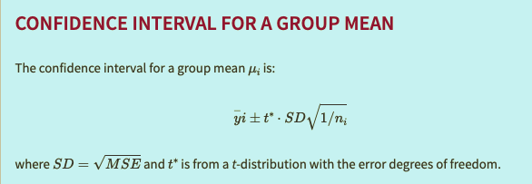
* For difference in means of two groups, REFERENCE beginning of semester, HIGHLIGHT common SD term as the distinguishing feature of these methods
* 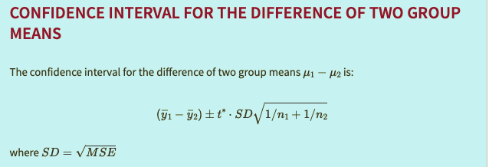
* ASK - why not separate the data into subset and analyze individually?
* Introduce multiple comparisons problem and ask students to read over R worksheet for next class

Notes:

Finished prep early: yes and yes

Finished class early: yes and yes

1. F

Agenda

* Assumptions discussion - WHY transform Y?
  + linearity assumption in MLR, in ANOVA additive and constant effects (additive just means no interaction effects, not really an assumption, just a feature of a one-way ANOVA)
    - add/interaction = effect on Y of any particular level change is/is not the same for every fixed value of the other predictor(s)
  + Constant variance
  + Sec 5.6 choose scale for response,
    - ANOVA diagnostic plot and table: look at log(group means) vs log(group sd's)
  + David Moore, “No one has ever invented a data analysis tool that beats the combination of the human eye and brain.“
  + Assumptions are difficult to prove, easier to disprove
* Sec 5.7 multiple comparisons worksheet
  + Effect size - review, what is it in ANOVA context? (takes into account standard error/sampling variability in addition to point estimate)
  + Fisher - least significant difference
  + False alarm rate = false discovery rate; individual vs group
  + Which error matters more?” - Type I or Type II ; multiple comparisons procedures only help with controlling the overall Type I error
  + Reference books step-by-step description of LSD (will do in worksheet next class)
  + Mention: Bonferroni adjustment for multiple comparison Tukey's honest significant difference; use same PostHocTest function but specify method as "hsd", "bonferroni", or "scheffe"
  + Just pairwise comparisons, not contrasts
  + Equivalence between hypotheses and ANOVA tests

MLR form: k = # of predictor terms (non-beta_0s); df_mod = k, df_e = n-k-1, df_tot = n-1

Group effects/means form: k = # of levels for single predictor varb (note # of terms in MLR form is k-1); df_mod=k-1, df_e = n-k, df_tot=n-1

* HW 4 prob 5 and ANOVA question: ASK - why not separate the data into subset and analyze individually?
  + Fitting a model, asserting information in all variables contribute to relationship
  + Compare SLR vs ANOVA data sets (n=10) and estimating variability of response varb

Notes: additive assumption = no interaction effects (not necessary assumption really, but in models with >1 categorical predictor, need to assess constant variance over every combination of levels from each); covariate means numeric predictor in a model with categorical predictors/explanatory varbs

Finished prep early: no

Finished class early: no in Sec 1, no in SEc 2

### Week 14

1. M

Agenda

* Sec 5.7 multiple comparisons worksheet exercises
  + H0: \beta_2 - \beta_1 = 0 or \beta_2 - \beta_2 = 0 are valid and NOT H0: \beta_1=\beta_2=0 (consider alternatives)
  + ASK which is reference group and what is X1 and X2 based on R Summary
  + Fisher LSD more liberal vs bonferoni conservative and Tukey HSD moderate; Fisher's LSD does NOT control the familywise type I error rate, instead order matters and it should only be applied after overall F-test is rejected
* “statistically significant” means “too big to be due just to unit-to-unit variation,” or, more briefly, “statistically detectable” vs practically significant/meaningful
  + Neither the P-value nor the margin of error tells us anything at all about whether the differences we have detected and estimated matter in practically. For that, we need estimates of mu/betas/effect sizes.
* Reflection prompt (7 mins strict)

Notes:

Finished prep early: yes

Finished class early: no and no

1. W

Agenda

* Review
* Stewardship discussion revisit
  + How data is obtained - observational vs experimental; scope of conclusions expanding to reasons why association exists (random assignment)
  + How data is obtained - random sampling and independence; scope of conclusions regarding meaning of p-values/CIs, patterns in sample vs patters in larger population
  + How data is analyzed - “exploratory” and “confirmatory” to label the two competing goals and two corresponding types of error in statistics. As Tukey and many others have said, you should be extremely careful about using the same dataset for both exploration and confirmation. estimation/prediction vs inference. (Multiple comparisons)
  + How data is analyzed - validity/reliability of models and tests/methods used (collecting evidence again assumptions like linearity, const. Variance, normality)

|  |  | Random assignment | |
| --- | --- | --- | --- |
| Random selection |  | Yes | No |
| Yes | Causal (pattern and reason); generalize to pop | Pattern; generalize to pop |
| No | Causal (pattern and reason); only for sample | Pattern; only for sample |

* + ASA PRINCIPLE B: Integrity of Data and Methods (ASA Guidelines) - call on students to read each one
* Review questions
* Where to go from here? Introduce extensions of MLR
  + (attach notes)

Notes: students interested in time series asking what to take (math modeling or stochastic processes)

Finished prep early: yes

Finished class early: no and no

1. F

Agenda: Final project presentations; bring food; peer review stuff ready